JJIF

SPORTS RULES

SELF-DEFENCE FOR THE ARMY, POLICE AND SECURITY COMPANIES
/Security Self-Defence/

Section 1. Essence
The Self-Defence Department for the Army, Police and Security Companies to JJIF (the Ju-Jitsu International Federation), aims to assist the education of officers from the law-enforcement bodies; one of the ideas is to carry out championships.

The “Security Self-Defence” Discipline represents a demonstration of defence against different types of attacks between competitors from one team. The attacks are defined and systemized in 4 groups – each one consisting of 4 attacks. The competitors are free to choose for themselves the defence technique to be used.

Section 2. Members of the Team
а/ The team comprises of 2 competitors, without any restrictions as to weight, age, gender or Dan;
b/ the competitors are bound to shoulder responsibility for each other;
c/ each country is to work out an archive with records of all practicing security self defence – from police, army, and security companies.

Section 3. Competition Area and Organisation
а/ The Competition Area is 10 x 10 m; it includes fighting area 8 x 8 m, and safety area 1 x 1 m;
b/ The whole area, as specified above, is to be covered with a 4-cm tatami. The colour of the safety area should be different than of the fighting area;
c/ All hard and dangerous objects should be kept at least 2 m. away from the safety area. It is allowed to have a chair for the coach near the tatami. The distance between the audience and the safety area should be at least 3 m;
d/ The Secretariat is to comprise of at least 2 persons.

Note:
The Director who happens to be authorized by JJIF to be in charge of the competition, checks the condition of the tatami before the beginning of each championship itself. During the championship the referees are responsible for the condition of the tatami, as per the set Rules.

Section 4. Competition clothing
The competitors are supposed to be dressed in the standard kimono.
The competitor in the defence position, “Uke”, should wear a tactical belt.
The name of the country and the type of the law-enforcement body should be displayed on the back of the jacket in a square 30/30 cm.
For example:
BUL BUL BUL
ARM POL SEC

Section 5. Training Aids
а/ The tactical belt must be made of textile material or leather; it should have a special holder for hand-cuffs and truncheon;
b/ The knife is made of rubber;
c/ The truncheon is plastic and should be 50-60 cm. long;
d/ The gun is made of wood or plastic;
e/ The hand-cuffs are of metal, with hard or flexible link.

Section 6. Personal requirements
- Clean and ironed kimonos
- Earrings, piercing, or any other sharp articles, that might injure or endanger the health of the opponent are not allowed;
- A competitor who has sight problems, can wear only soft sports glasses, or soft contact lenses, at his/her own responsibility;
- Long hairs should be tied up with soft hair-bands.

Section 7. Position at the beginning and in the end of the match
а/ The competition pairs should stand facing each other in the middle of the competition area – at a distance of 2 m. from each other;
b/ At the beginning of the Fighting the competitors make a standing bow first to the Mat Referee, and then to each other;
c/ In the end of the match the competitors make a standing bow first to each other, and then to the Mat Referee;

Section 8. Attacking and Defensive actions:
а/ The attacking actions must be real, well-shaped, with speed, strength and control.
They comprise 4 groups (series) – Attachment No. 1.
І – defence against grips, grappling and strangulation
ІІ – defence against strikes, blows and kicks
ІІІ – defence against knife and pointed gun
ІV – defence against truncheon, control with truncheon, defence with truncheon against strikes, preventing taking the truncheon away.

Each group consists of 4 attacks;
b/ The defence actions should be in the following sequence:
- Blocking, avoiding attacks, or anticipating actions (strike or throw)
- Disbalancing blow
- Control of the opponent
- Throwing down with a lock, or just a throw-down
- Ground control
- Body search and putting hand-cuffs (only during each third technique from the groups)
- Еаch technique must finish with taking the opponent away – as far as the end of the competition area.
Note: It is allowed the defence to be completed by control in a standing position and putting the hand-cuffs.

Section 9. The Fighting Match
а/ The fighting is between two couples. The teams are to be taken in and introduced with signs;
b/ The Mat Referee selects 3 attacks from each series;
c/ The first duo begins with the first series and gets scores for it; then the second duo makes the first series and gets scores for it;
The second duo begins with the 2nd series and gets scores for it, after which the first one makes the 2nd series and gets scores for it.
The first due begins the 3rd series, etc.; while the second duo – begins with the 4th series, etc.
This change is aimed at an objective assessment and presentation of the competitors.
Each third (last) technique from each series finishes with a body search and hand-cuffs putting, after the personal defence actions and the control. During this control commands are to be given in the respective language for purposes of respecting the opponent; the use of ugly words is not allowed;
d/ It is compulsory to strike a blow in order to break the balance of the opponent before the beginning of the attack;
e) For each new fight the “Attacker” and the “Defender” change their positions.

Section 10. Chief Referee, Mat Referee /MR/ and the Jury
а/ The Jury comprises of three (3) licensed referees – each one from a different country. The members of the Jury give the scores after indications given by the Mat Referee, by raising their marks high above their heads. These marks are to be put down after instruction given by the Mat Referee.
b) The Mat Referee stays within the competition area and is responsible for the match. He uses the cards specifying the attacks and helps visualize them. He signals the Jury whenever the attack is not the proper one;
c/ The Chief Referee controls the objectivity of the judging of the Jury; the proceeding of the match and the performance of the MR; if need should be, he is entitled to request re-consideration of the marks given. He announces the final scores of the match.

Section 11. “Hajime” and “Matte”
а/ The Mat Referee announces the number of an attack in order to declare the beginning of the fighting;
б/ The Mat Referee announces “Matte” to declare the end of the fighting.

Section 12. Criteria for assessment
а/ Correct technique (kihon);
b/ Attitude and Efficiency;
c/ Reality of the Performance;
d/ Focussing the Strength (Kime);
e/ Quick and Energetic Action;
f/ Control of the Technique;
g/ Control of the Actions of the Opponent;
h/ Adequate judgement on time and distance;
i/ Logical consequence of the actions and readiness for continuing the fight (Zanshin);
j/ Concentration of attention (Chakugan).

Section 13. Norms for Assessing
The attacks and the defence should be effected in a real and efficient way and comply to the following requirements:
а/ Strikes
- correct and clear-cut performance with the necessary strength, quickness, control and body balance
- correct and proper breathing
- withdrawing the hand and leg after “Hiki te” and “Hik ashi”
- they should lead naturally to the next move;
b/ Throws and getting down on the ground
- the opponent’s balance must be broken
- good balance, quickness and control
c/ Techniques for control and strangulation
- the above should be performed in a clear manner and be confirmed by tapping on behalf of the opponent – “Uke”, without causing any trauma whatsoever.
d/ Accessories (truncheon, handcuffs) –should be used in a manner that they should not hurt the partner. The handcuffs should be put quickly and energetically, with good technique; and after the defence, they are to be removed in 1 minute;
e/ The competitor in the defence position controls the weapons (knife, stick, gun) – from the very beginning until the end of the match;
f/ Interrelation – in percentages – between the various stages /Table 1/

Тable 1
Stages of Unfolding of the Action | Percentage % | Judging (0.5)
І stage – Attack and First Defence  ІІ Stage – Performing follow-up technical actions  ІІІ Stage – Establishing full control over the opponent and quickness of putting the handcuffs | 35 %  35 %  30 % | From 0 up to 3.5 points  From 0 up to 3.5 points  From 0 up to 3 points

Section 14. Giving the points
a) The Jury gives points after each series of 3 techniques and on the request of the Mat Referee;
b) Each member of the Jury judges a certain stage of the actions of the team and gives points according to Table 1;
c) The incorrect or weak attacks, unnecessary screams, uncontrolled and unreal or weak techniques, should be punished by deduction of points;
d) If a technique could not be completed by its end due to an accident, it should not be repeated. In such a case the Jury is to judge the other two techniques.

Section 15. Walk-Over and Withdrawal
a/ The decision of "Fusen-Gachi" (win by walk-over) shall be given to the competing couple whose opponents do not appear for their match, after they have been called for 3 times within a total of 3 minutes.
b/ The decision of "Kiken-Gachi" (win by withdrawal) shall be given to the competing couple whose opponents withdraw from the contest during the match itself.
Section 16. Settlement of the Match
If the competing couples have equal points at the end of the match, they repeat the match until there is a difference in the overall score achieved at the end of a series. In this second round of competition the MR draws new attacks from his/her cards and the couple with blue belts starts series 1, etc.

Section 17. Injury, Illness or Accident
a/ When an injury, illness or accident occurs, the active couple has the right to a maximum time of 5 minutes rest before continuing (the total rest time per couple in each match shall be 5 minutes);
b/ If a couple cannot continue after an injury, "Kiken-Gachi" is given to the other couple.
Section 18. Situations not provided for by this Regulation
Any situation which arises, and which is not covered by these rules, must be dealt with by the Referee Council, comprising of three referees of the highest category; this Council is to be appointed by the Chief Referee of the respective competition.

Section 19. Behaviour of the coaches
Only one coach who will be entitled to stay by the marked border of the competition area during the match has the right to help competitors. If the coach behaves in an improper manner – towards the competitors, the judges, the audience, or anybody else) the Mat Referee is entitled to make this Coach leave the area reserved for the officials, for the rest of the match. If this improper behaviour continues, the Mat Referee can decide that the Coach should leave this area for the entire duration of the match.
Annex 1

GROUP 1  Grappling Attack  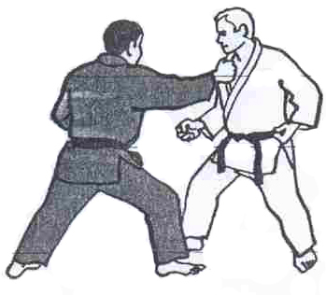  Attack 1 | GROUP 1  Embracing Attack  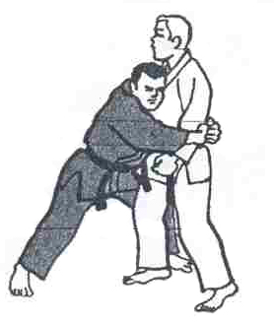  Attack 2 | GROUP 1  Strangulation Attack  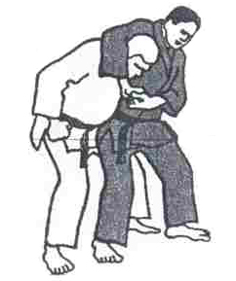  Аttack 3
GROUP 1
Strangulation Attack

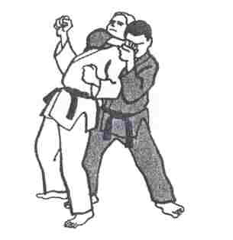
Аttack 4

GROUP 2  Attack with punches  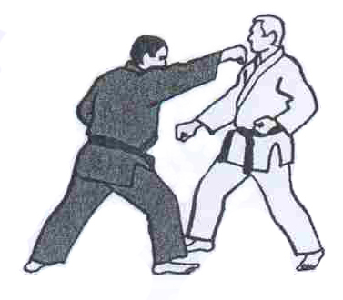  Attack 1 | GROUP 2  Attack with strikes  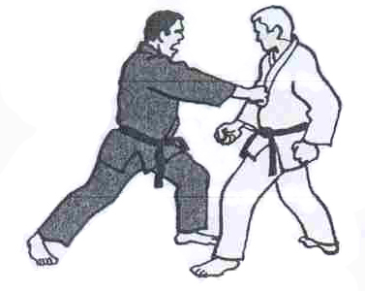  Attack 2 | GROUP 2  Attack with kicks  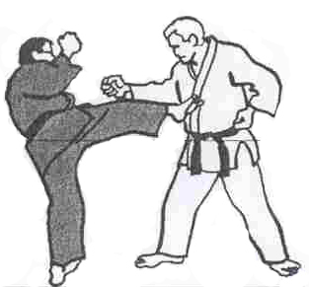  Attack 3
GROUP 2
Attack with kicks

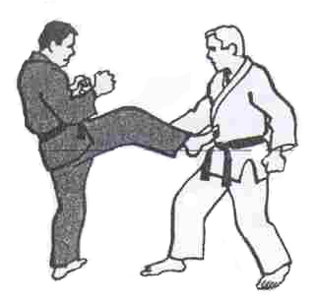

Attack 4
GROUP 3  Attack with knife  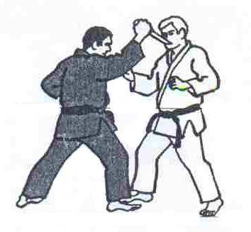  Attack 1 | GROUP 3  Attack with knife  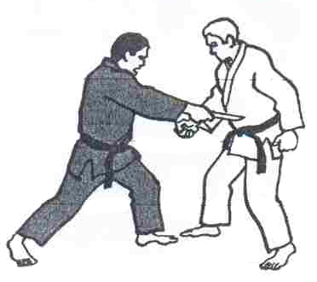  Attack 2 | GROUP 3  Defence against a pointed gun – from in front  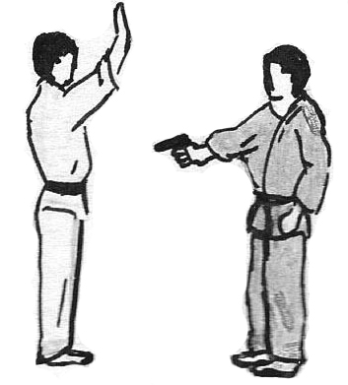  Attack 3
GROUP 3
Defence against a pointed gun – from behind
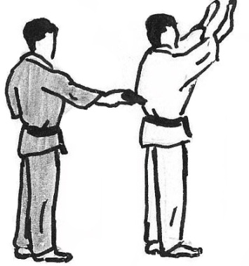

Attack 4

GROUP 4  Defence with a stick against strikes  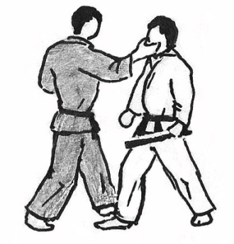  Attack 1 | GROUP 4  Preventing taking away the stick  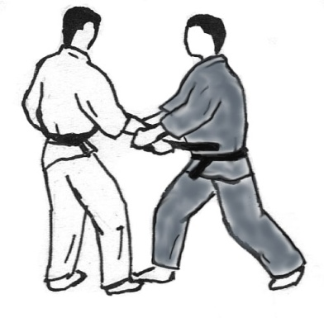  Attack 2 | GROUP 4  Control and detaining with a stick  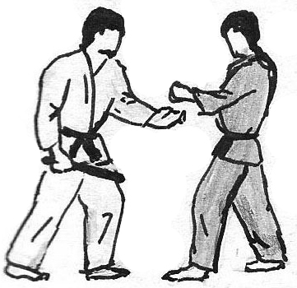  Attack 3
GROUP 4
Defence against a strike with a stick

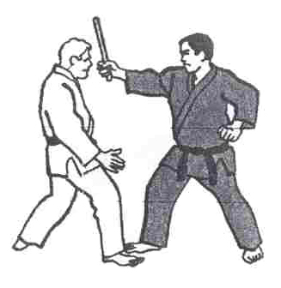

Attack 4

